
SAT LAB Online Tutoring
Spring 2013
Welcome CSUN students to the Subject Area Tutoring Lab online program for Fall 2012. This semester we are using Moodle and Collaborate chat rooms powered by Blackboard as our new online platform for tutoring.
This is a step-by-step guide on how to access our tutoring page on Moodle and how to navigate the Blackboard Collaborate chat room.
Please note: Once you have accessed the page, complete the system requirement test to make sure your computer can support chat rooms.

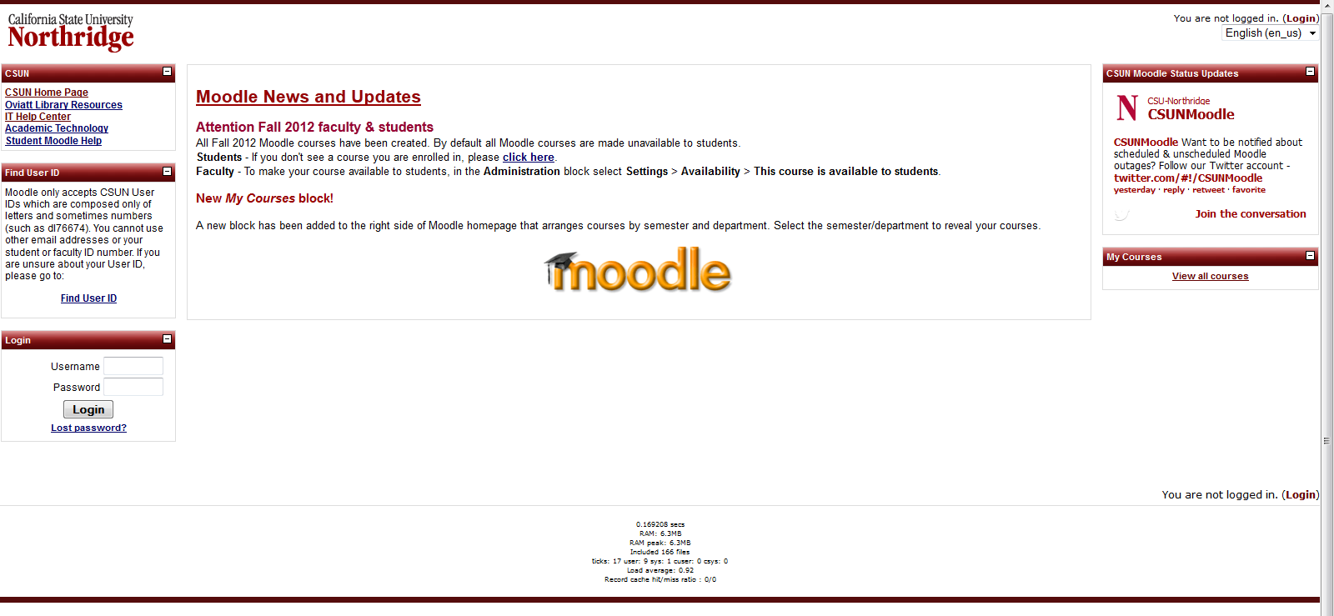
Step 1: Log-in to Moodle

Step 2: Search for Subject Area Tutoring Lab
Scroll down to the bottom of the page, and type Subject Area Tutoring Lab into the search bar.
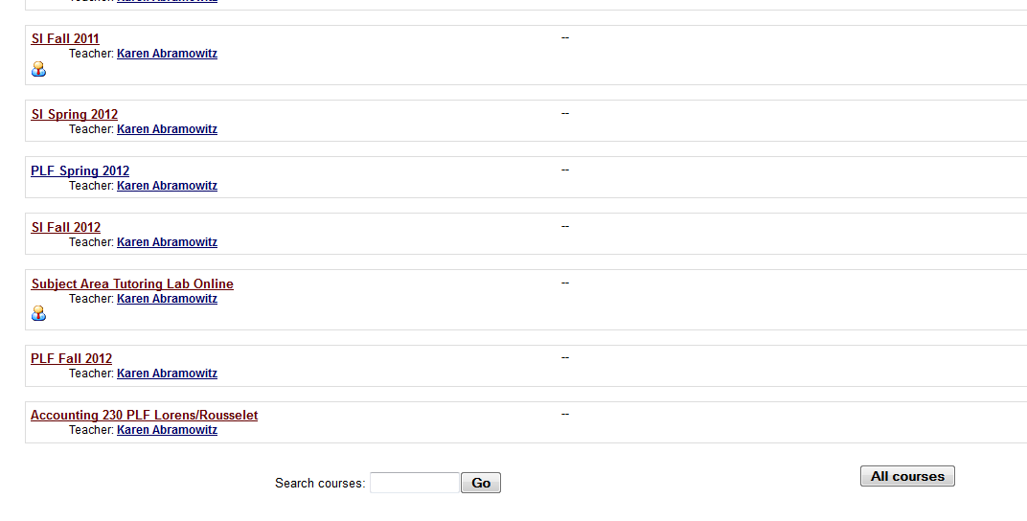

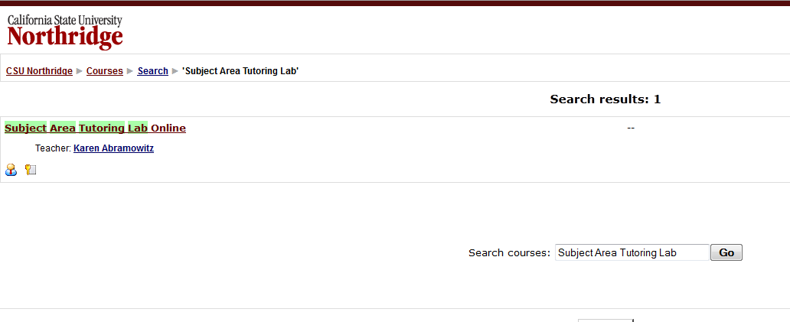
Once you search for this course, the SAT Online link will come up in the results.

Step 3: Access the page and enroll in the course
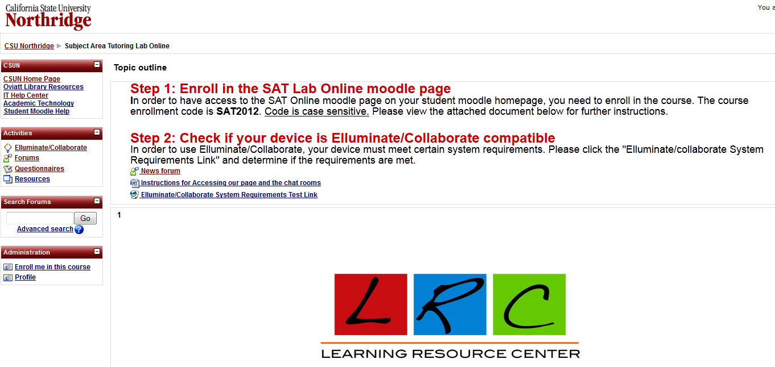
Now you can access the SAT LAB online tutoring page.
At this point, you will only have guest access. You must enter the enrollment code for the page in order to access the online chat room with tutors. The code is SAT2013.

Step 4: Once you enroll in the course, you can access the chat rooms and be tutored online!
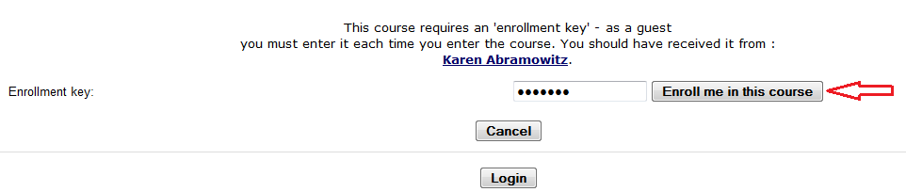

Accessing Chat Rooms
Once you have enrolled and have checked if your computer has the necessary system requirements, the SAT Lab online tutoring page should always show up on your Moodle front page.
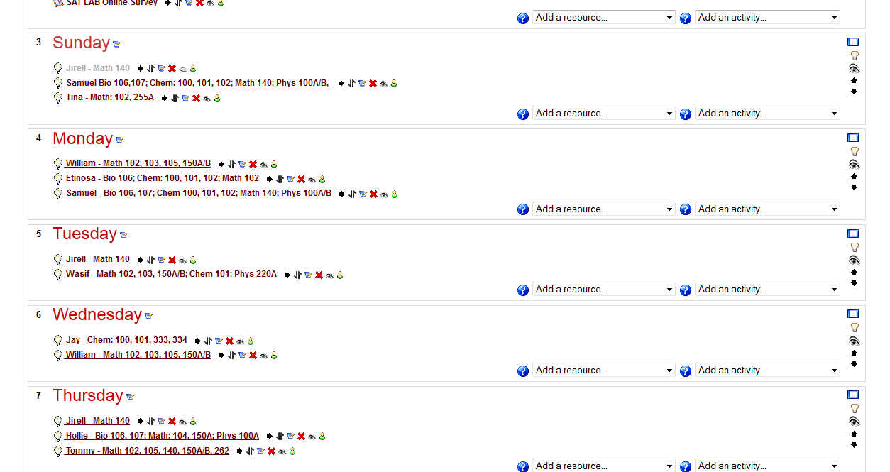
Step 1: To enter the chat room, scroll down and locate the day and tutor you wish to see.

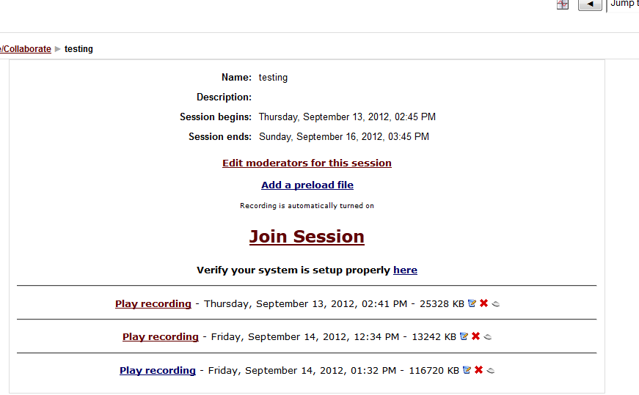
Step 2: Click join session.

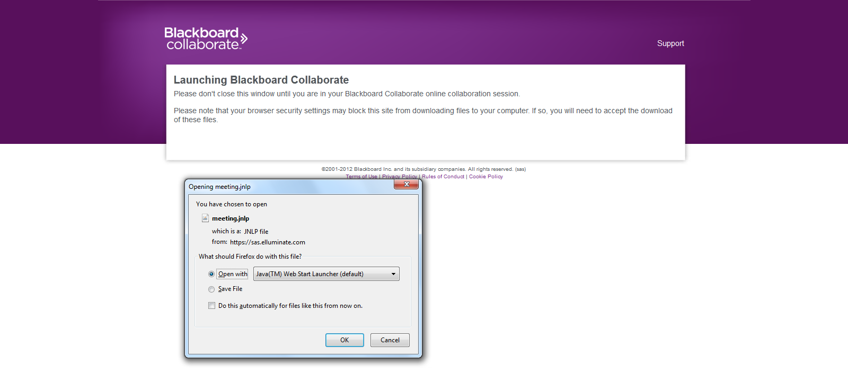
A new window will open, prompting you to launch Blackboard Collaborate. The program should automatically open with Java. Click Ok.

A window asking if you want to run the application will pop up. Click Run.
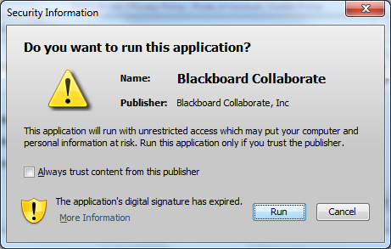
Finally, the Collaborate chat room will load, and the tutor will be available to help you.

